New Yorker Cartoonist Envisions a Ride on the Subway Sofa
By Nancy Lazarus on Apr. 7, 2016 - 3:42 PM
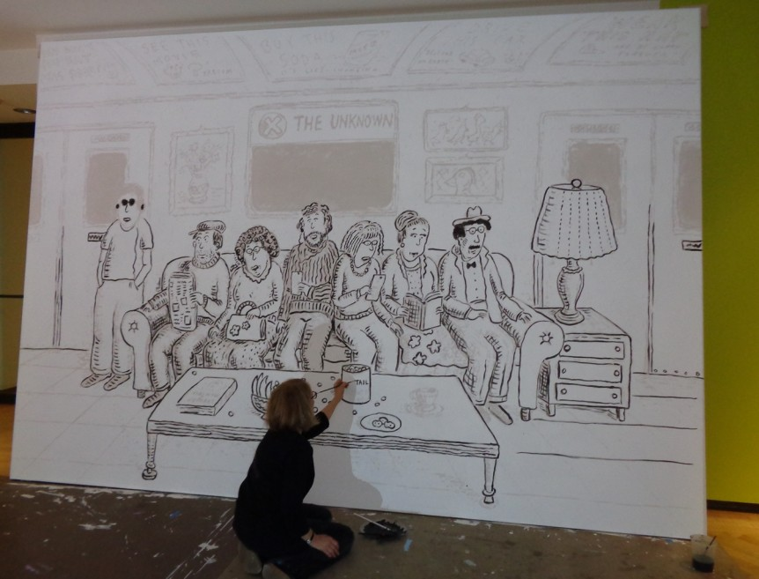
In an era when the prospect of venturing down to the subway sparks apprehension among most urban residents, Roz Chast, longtime cartoonist for The New Yorker, has the perfect antidote: a larger than life portrayal of a subway ride on the fictitious “X” train to destination “unknown.”
The installation will be showcased at the entrance to an exhibit at MCNY/ Museum of the City of New York, entitled Roz Chast: Cartoon Memoirs. Over 200 works will be on display, many never before published, and will open to the public April 14.
For now the mural is a work in progress, and FishbowlNY got a preview last week. “I’ve never done anything on this scale before,” said Chast as she painted the outline of her sketch projected onto a wall-sized canvas. As she completes the multi-day project, cameras are recording for a time-lapse video. (The final work will be in black and white, while the cartoon version is in color).
Chast, a native New Yorker who now resides in Connecticut, prefers to convey timeless themesrather than the latest topic of the day. “Here she combined a couple of her favorite subjects, cramped NYC apartments and the hassles of taking the subway,” said exhibition curator Frances Rosenfeld. The result is an interesting mix of interior and exterior settings.
The cast of seven characters on this metro ride are a quirky and eclectic group, engaged in separate activities to pass the time. With all the cozy amenities, like the couch, reading lamp, scenic paintings and coffee table stocked with cocktail peanuts, this ride seems to be going quite smoothly. Though as anyone who has taken the subway knows–even the possible future commander-in-chief–that could change in a New York minute.
